"The Well is still in love with this theory that two young, successful people are killing a woman for no reason," says Knox's ex-boyfriend Raffaclc Sollecito, who, like her, spent four years innocently behind bars. "Because the story contains everything: Sex, beauty. Blood. She was a fairy tale, but she destroyed our lives."

Every day, Christopher Robinson opens the messages his wife receives via email and social media: He scans them for death threats. "You killed a young woman, so don't cry," someone writes. "You deserve to die."Others wish Knox's baby or her husband death. "The worst are the worst. that will become concrete," says Robinson. "Something like: "I'll put you in a van without

FOREIGN COUNTRY

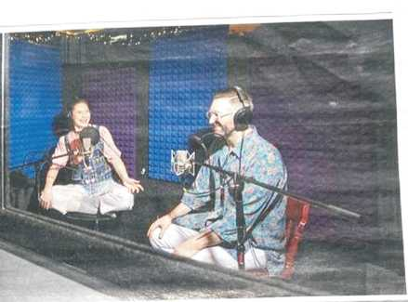

I

lead^and rape until you get around '

Grace begs.< I send it directly to the FBI."

Amand3 Knox lost every sense of security through the misjudgment. "Once everything has been taken from you, you fear that it will happen again," says himself. Her ingenuity made her anxious: Knox often dreams that her husband is dying or something happens to her daughter. But knowing how fragile their existence is. made her free. "I know there's no guarantee of anything," she says. "That's why I try to live every day as well as I can."

Knox, daughter of a primary school teacher and an accountant, grew up in sheltered conditions: Nothing bad had ever happened to her until she was arrested in Perugia. Friends and family describe her as good-natured to naive. "I was so un-! "Honorable." Knox says about her early I res I. "I was a kid."

What she experienced in prison and in court shook Knox" world 1 picture. "I used to think: All the people behind bars are evil and deserve their judgment. Today I know: It's much more complicated."

While in custody, she played cards with a woman who had overwhelmed and killed her, and shared them with a former drug ku. The closer Knox came to them, 1 lesto more often she wondered: Could the old have been prevented if the women were helped - :e? If they had not been born in broken families, but in loving ones?

During the first weeks of her imprisonment, Knox remembered life I

Podcaster Knox,

Robinson: Every day in public is a day in court

i

"The investigators were probably afraid of losing their face. They couldn't admit:

We were wrong."

Nina Burleigh, journalist

in one dose. The idea, she says. ' scared and reassured her equally. It was a door that was always open, and Knox decided every day not to go through.

She jogged endless rounds on the prison yard. a concrete field surrounded by meter-high walls. Learning to roll out pizza dough with a broomstick because there was no pasta wood in the jail. Knox perftio- s introduced her to Italian and began to translate for the women in the tract: Many were migrant women and could neither read nor write. Knox wrote letters to her families and explained the pain of the women to the prison doctor. "I tried to create something that counts every day," she says.

When she left the prison in 2011 after four years, she had lost the I faith in good - but gained more sympathy for the-supposedly I bad people. In 1 2014, her mother persuaded her to go to a conference of the Innocence Project, an organization that works for victims of justice. In tears, Knox tells the students in Ohio how they first met people who had been convicted of the same crime. "I was so nervous that I hyper-ventilated," Knox recalls. "But when I entered the hall, two men immediately hugged me. They said: Little sister, we know exactly how you are. You don't have to explain anything."

Former prisoners, often twice the age of Knox, became their closest confidants. It's another reason why they are concerned about their case

says: She wants to draw attention to the fate of these mostly black men, with whom she associates more than with any blonde American.

The years in prison, says Knox, have changed them and separated them from some people. She got closer to others. A friend told Knox after her return that she had been raped as a teenager - a trauma she never talked about. A woman wrote to her about her cancer diagnosis and feeling trapped in her body.

Knox gets messages where people trust her.

1 how they were wrongly condemned or lost a child. "That something bad happened to me gives them the courage to share their own bad experiences," says Knox.

Meanwhile, there are more people who thank her than people who wish her death. Knox answers each and every individual. "I want them to feel seen," she says. "And I like to show: I'm not a monster. I'm not the person the world thinks I am."

But no matter what Amanda Knox does, millions of people around the world will continue to believe that she is a murderer. "No verdict will ever convince her" that Amanda Knox is innocent, says journalist Nina Burleigh, who accompanied the case for years. "You'll always see in it this creature that the prosecution and the media created."

Rudy Guedc, the murderer of Me-redith Kercher, was released in November 2002" after good leadership. Amanda Knox remains imprisoned to this day. ■

’/12.2.2022 OR **MIRRORS** 87